

System Identification

Report – Work Assignment 3

**Nonlinear Optimization Algorithms**

**Instructor:** Telmo Cunha

MIEET

**Authors:** Rui Carapinha, 79970

Vadson Culanda, 79988

**Date:** 22/12/2019

1. **Introduction and Objectives**

Optimization methods are very important tools when it comes to identification systems. Up to now we have mostly dealt with models that are linear in the parameters, for which linear least squares can be applied to calculate the model parameters. However, linear Optimization cannot be applied to systems which are nonlinear in the parameters and that’s the case for this work assignment. Therefore, we’ll need to apply nonlinear optimization methods in order to estimate the three parameters of an amplifying electronic circuit, namely, the inductance 𝐿 of a coil (which can be between 10 𝑚𝐻 and 20 𝑚𝐻), the capacitance 𝐶 of a capacitor (which can be between 10 𝜇𝐹 and 20 𝜇𝐹), and a parameter 𝑇1 associated with the internal behavior of the FET used in the amplifier (which can be between 1.0 and 1.5).

There are several nonlinear optimization methods we can implement in order to extract these parameters, like The Gradient Descent, The Simulated Annealing, Nedler-Mead Simplex and Levenberg-Marquardt.

1. **Approach**

In the elearning we have available two different function which allows us to test the circuit, GetReferenceSignals(StudentNumber), which returns the samples of the input signal vi and the respective output signal vo, and the function Circuit(vi,t,L,C,T1) which returns the output signal for the three parameters. Every time the function Circuit is called, an electronic circuit simulator algorithm is executed, which naturally takes a considerable amount of time to simulate. Thus, we need to implement an algorithm which is computational efficient. The approach we decided to take was the following:

We started with a random location (in all parameters) and calculated the error function for that location. After this we applied 2 algorithms:

1. The first one was the Nelder-Mead Simplex to obtain a relatively good approximation to the error function global minimum.
2. The second one was the Gradient Descent (fixed-step algorithm), that will allow us to converge to the function global minimum.

If we only used the second algorithm we could be stuck in a local minimum, the first one will have a bigger probability to avoid that. In the first algorithm the stop conditions are given by 3 factors, 2 of them are thresholds:

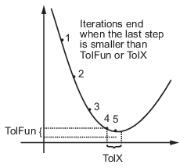

1. TolX – lower bound on the size of the step. We defined this one as 1.
2. TolFun – lower bound on the change in the value of the error function during a step. We defined this one as 1.
3. Iterations – We used the default MATLAB value, 200*numberOfVariables.

The second algorithm is stopped by a threshold (we defined as 10-10) or the number of iterations (we defined as 10000).

1. **Results**

We are trying to model the following circuit response to vi:

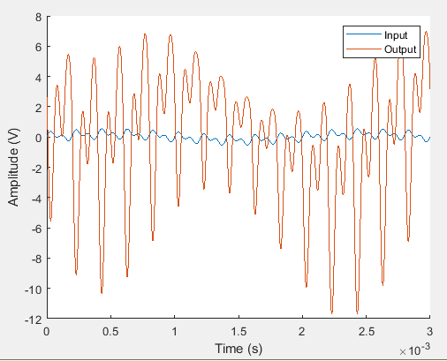

Figure - Circuit Response

We started the algorithm with L = 19.1367 mH, C = 16.3233 μF and T1 = 1.0487 (randomly obtained). The NMSE obtained for this set of parameters was -21.7364dB. These values led to the following model response to the same vi:

Figure - Model First Response

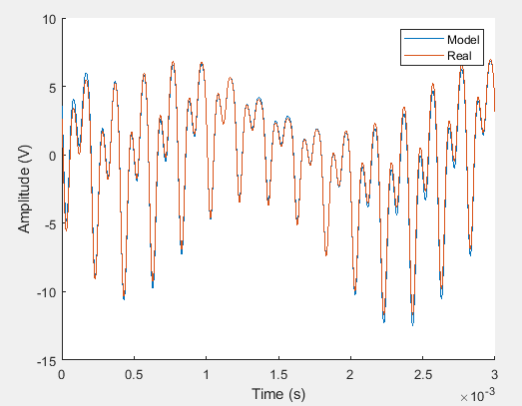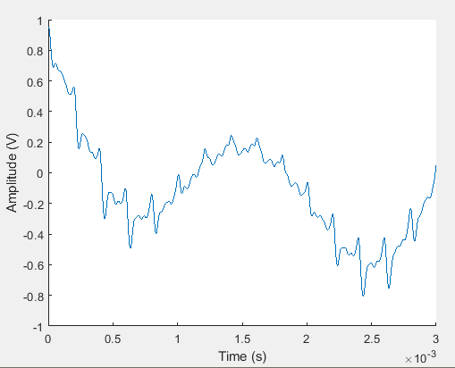

After we runned the first algorithm, we obtained the following set of parameters L = 16.0286 mH, C = 15.9794 μF and T1 = 1.2006. The NMSE for this set of parameters was -55.9499dB.

After this, despite we already obtained a good NMSE value we runned the first algorithm, we obtained the following set of parameters L = 15.9986 mH, C = 15.9994 μF and T1 = 1.1999. The NMSE for this set of parameters was -85.5248dB. These values led to the following model response to the same vi:

Figure - Model Final Result

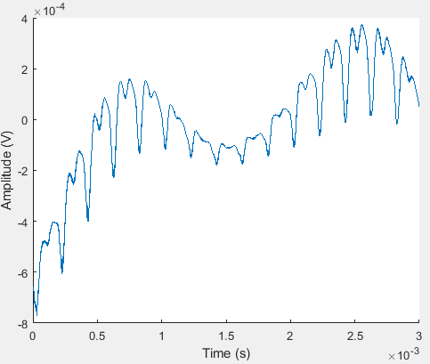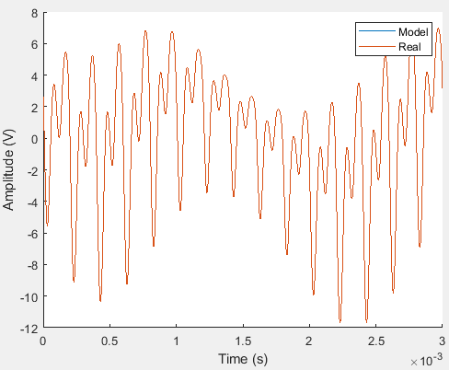

1. **Conclusion**

This work was important to us to get familiarized with the nonlinear dynamic system, namely, to learn how to properly study the system. In the first part we executed different tests using a 2 tone signal and varying the amplitude and frequency of the input signals. That way, we can study the behavioral of the signal and its response to different excitation signals. We observed that for frequencies below 100 Hz the system behaved like an attenuator and above that as an amplifier. We also notice that gain was dependent on the frequency, for frequency below 680 Hz the higher the frequency the higher the gain and for frequencies above 800 Hz the higher the frequency the lower the gain. We also noticed that between the frequencies of 680 Hz and 800Hz the system presented a linear behavior, the gain was constant and independent of the frequency. Therefore, we concluded that this system didn’t amplified all the signals in the same way, it behaved like a band pass filter, with a constant gain between 680-800Hz. The also observed the nonlinear behavior of the system by the components of the signal present in the harmonics of the input signal.